Your Character
Questions about Yourself/The Character you want to represent you in the world
This character should represent who your preferred self would be in a world full of supernatural/magical powers, limited government and law enforcement. Strong powers are coveted and hunted for by some.
This is an example of the city/world the story will take place in
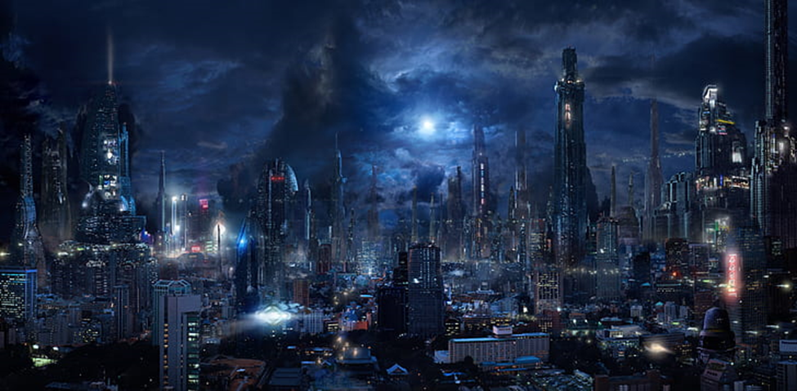
All answers have the possibility of follow-up questions to narrow down the character and their arc
Final Note: If any questions are too personal, or you do not know yet, feel free to leave them Blank, and we will work on them at a later date or brush past them in the story
Question 1 – If you could do anything in the real world as a career/job—and you would make enough money to live comfortably—what would you want to do and why?

Question 2 – If you could have any kind of superpower, what would it be?

Question 3 – Which character—from any medium—do you feel a kinship with the most?

~TRIGGER WARNING~ Question 4 – If your character saw someone in this world being beaten and robbed, what would they do and why?

Question 5 – What is your character's sexuality? (All sexualities are welcomed)

Question 6 – Describe your perfect day.

Question 7 – What age do you want your character to be?

Question 8 – What time of year is your character's favorite?

~TRIGGER WARNING~ Question 9 – What—if any—scars do you want your character to have?

~TRIGGER WARNING~ Question 10 – What would your character do if their life was being threatened? Run, fight, freeze, or something else entirely?

Question 11 – What is the preferred style your character would wear? (Images can be sent separately for visual aid.)

Question 12 – What gender/sex would you want the character? (All genders/sexes are welcome)

Question 13 – Describe the look of your character—i.e., eyes, hair/length, frame, height, and build.

Question 14 - Do you want your character to be good, evil, neutral, or something in between? (ie: hero, anti-hero, vigilante, undefined, other)

Question 15 - Introvert, Extrovert, or Ambivert?

Final Question – What do you want your character’s name to be? (Your preferred name would work best, and I must retain rights to change the name in the story if need be)

